If you’ve encountered this issue, even after disabling signature varification and enabled test signing via bcdedit, then keep on reading to see my fix.

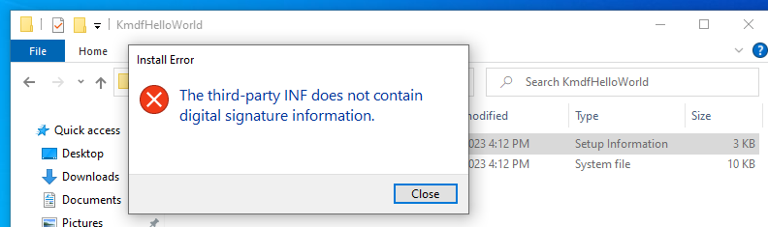

First, check if the .cat file was generated. A catalog file contains multiple signatures, each signature corresponds to a single file that’s installed by installing the driver (or copied to another directory by installing the driver). <https://learn.microsoft.com/en-us/windows-hardware/drivers/install/inf-copyfiles-directive>

If there isn’t a .cat file, you need to ensure inf2cat is being instructed to generate the catalog file on Visual Studio. Right click on “Project” (instead of “Solution”), and then “Properties”.

Select “No”, which means do generate the catalog file.

If inf2cat is still not generating the catalog file, delete inf2cat.exe.manifest so that Visual Studio would sign the catalog. <https://developercommunity.visualstudio.com/t/inf2cat-an-attempt-was-made-to-load-a-program-with/785173>

The installation should work fine from here on. Copy the “.inf, .cat, .sys” into your target machine, right click on the “.inf” file and then “Install”.

If the following popup shows up but you can’t find your device on “Computer Management”, and DebugView isn’t showing kernel messages, my fix is provided below.

First, ensure DebugView is instructed to capture everything:

And install a device using devcon.exe, find out the “Hardware ID” like this:

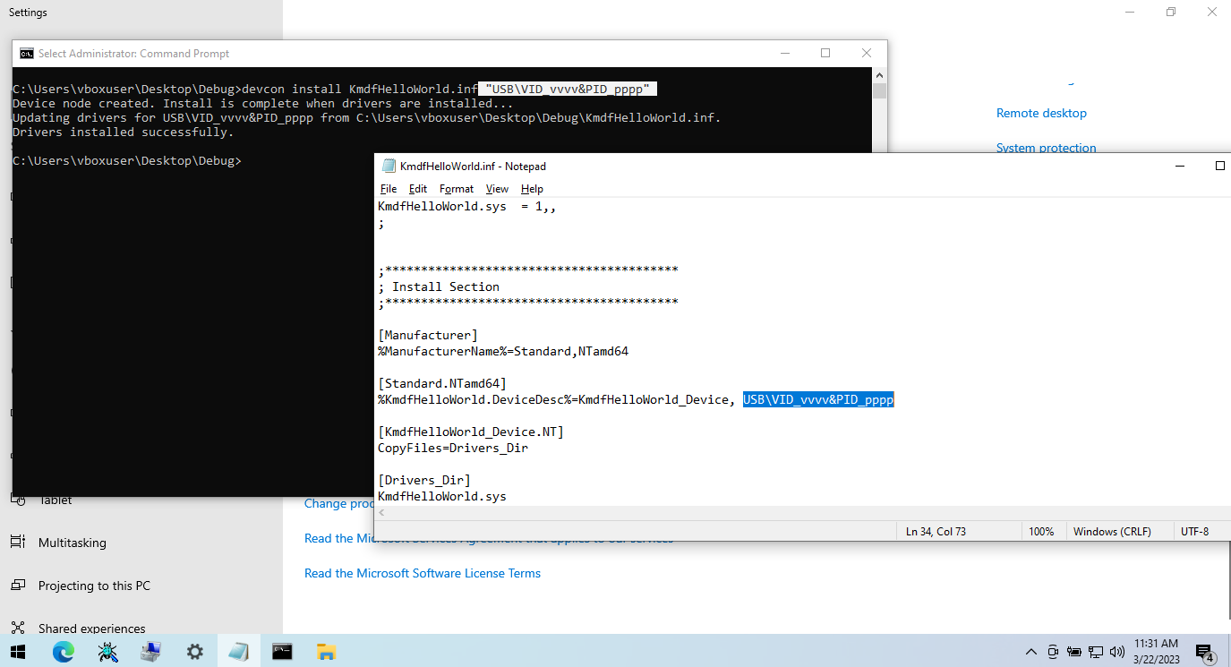

Right after installing the driver, you should be able to see something like this in DebugView.

This is exactly what we wanted the driver to print by calling KdPrintEx.

